SUGAR VALLEY LAKE HOMES ASSOC., INC.
Annual Members’ Meeting
January 23, 2021 @ 9:00 am - 4-H Building, Mound City, KS
Call to Order:
Pledge of Allegiance led by Janet St. Clair-Hays
Invocation led by Steve Spencer
Introduction of:

- Board Members: Mike Barrett, Loren Lance, Cory Schnabel, Janet St.Clair-Hays,
David Eastwood
- General Manager: Steve Spencer

- Attorney: Burton Harding
- Recording Secretary: Kim Cunningham
- Teller Committee: Vicki Capp - Chair, Ronda Hague, Charlotte Rhynerson, and
Karen Barrett
- Sergeant-at-Arms: Joe Cunningham

- Candidates: SVL: Brenda Hallstrom, Michael Iverson, David Zyla
HVL: David Eastwood, Loren Lance
Last Call for marked Ballots
Ballots removed for counting
Approval of minutes from the January 2020 meeting
Motion to approve Loren Lance, Second Mike Barrett, Motion passed.

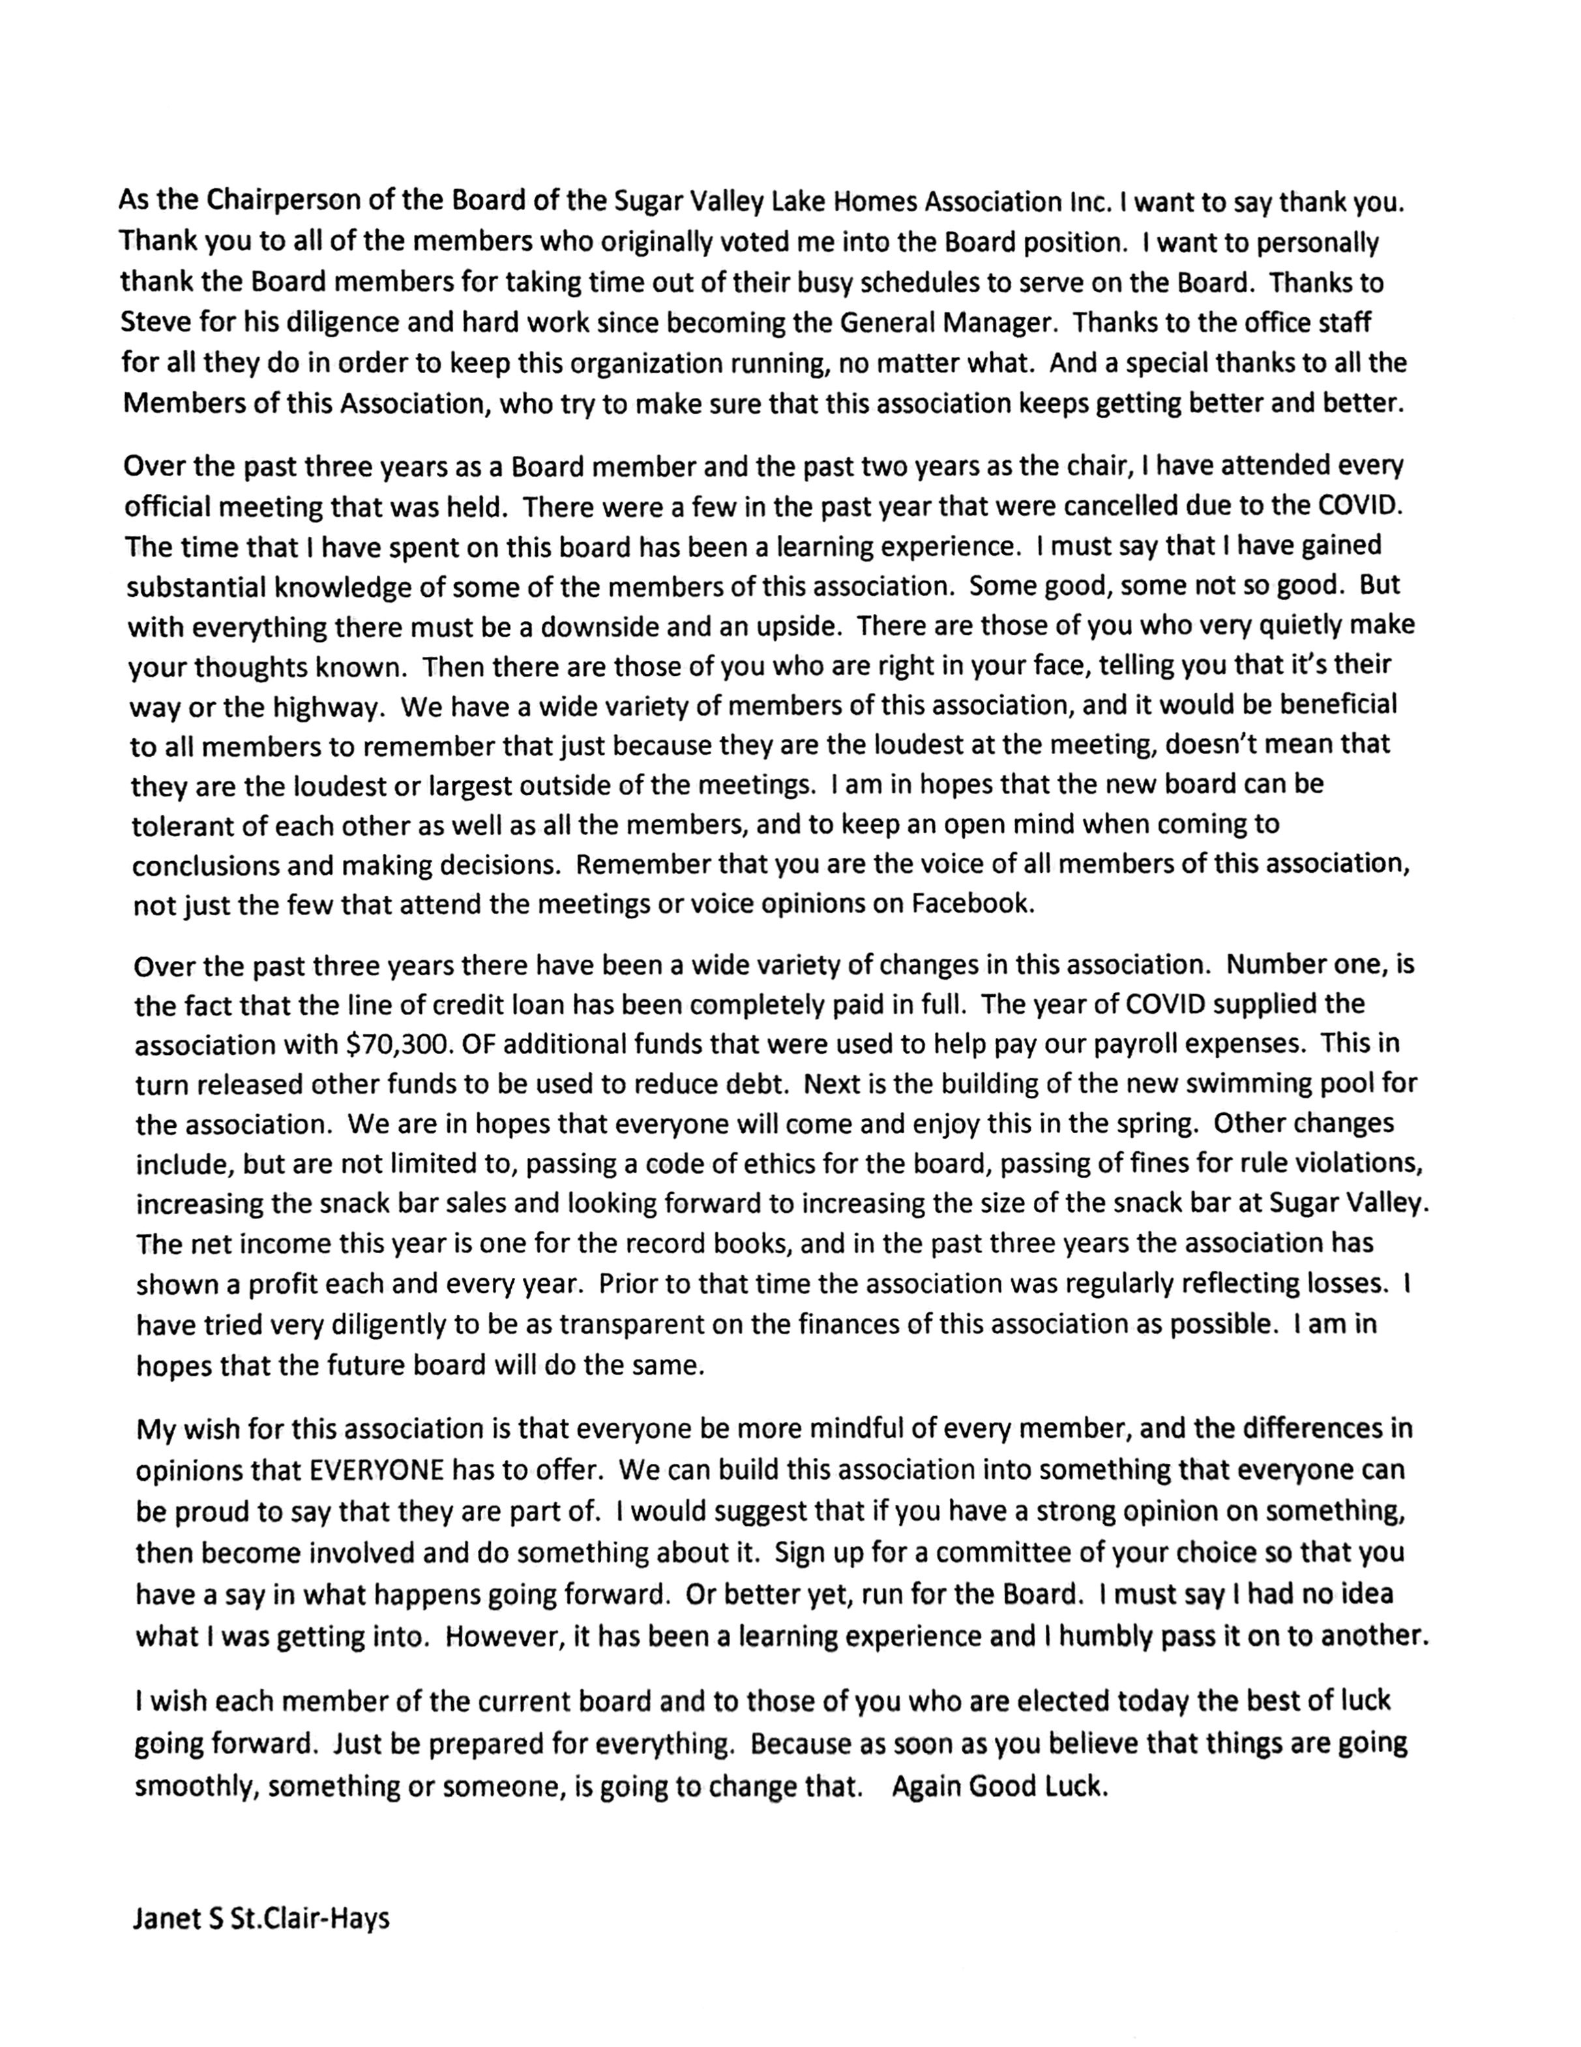
Chairman of the Board Report
As the Chairperson of the Board of the Sugar Valley Lake Homes Association Inc. IwantI to say thank you. Thank you to all of the members who originally voted me into the Board position. want to personally thank the Board members for taking time out of their busy schedules to serve on the Board. Thanks to Steve for his diligence and hard work since becoming the General Manager. Thanks to the office staff for all they do in order to keep this organization running, no matter what. And a special thanks to all the Members of this Association, who try to make sure that this association keeps getting better and better.
Over the past three years as a Board member and the past two years as the chair, ^{I} have attended every official meeting that was held. There were a few in the past year that were cancelled due to the COVID. The time that have spent on this board has been a learning experience. ^{I} must say that ^{I} have gained substantial knowledge of some of the members of this association. Some good, some not so good. But with everything there must be a downside and an upside. There are those of you who very quietly make your thoughts known. Then there are those of you who are right in your face, telling you that it's their way or the highway. We have a wide variety of members of this association, and it would be beneficial
to all members to remember that just because they are the loudest at the meeting, doesn't mean that they are the loudest or largest outside of the meetings. ^{I} am in hopes that the new board can be
tolerant of each other as well as all the members, and to keep an open mind when coming to conclusions and making decisions. Remember that you are the voice of all members of this association, not just the few that attend the meetings or voice opinions on Facebook.
Over the past three years there have been a wide variety of changes in this association. Number one, is the fact that the line of credit loan has been completely paid in ful. The year of COVID supplied the
association with $70,300. OF additional funds that were used to help pay our payroll expenses. This in turn released other funds to be used to reduce debt. Next is the building of the new swimming pool for the association. We are in hopes that everyone will come and enjoy this in the spring. Other changes include, but are not limited to, passing a code of ethics for the board, passing of fines for rule violations, increasing the snack bar sales and looking forward to increasing the size of the snack bar at Sugar Valley. The net income this year is one for the record books, and in the past three years the association has shown a profit each and every year. Prior to that time the association was regularly reflecting losses. have tried very diligently to be ^{as} transparent on the finances ofthis association as possible. Iam in hopes that the future board will do the same.
My wish for this association is that everyone be more mindful of every member, and the differences in opinions that EVERYONE has to offer. We can build this association into something that everyone can be proud to say that they are part of. ^{I} would suggest that if you have a strong opinion on something, then become involved and do something about it. Sign up for ª committee of your choice so that you have a say in what happens going forward. Or better yet, run for the Board. ^{I} must say I had no idea
what I was getting into. However, it has been a learning experience and ^{I} humbly pas it on to another.
^{I} wish each member of the current board and to those of you who are elected today the best of luck going forward. Just be prepared for everything. Because as soon as you believe that things are going
smoothly, something or someone, is going to change that. Again Good Luck.
Janet S St.Clair-Hays
Manager’s Report: Steve Spencer thanked the Board, Employees and Volunteers
We had a good year with lot sales totaling around $81,000, the price of lots are going up due to all the improvements made around the lakes. There have been a lot of building permits issued this past year.
The balance of the PPP Loan ($73,000) was forgiven this year, that freed up some financial resources.
Beach areas on both lakes were improved this year. There is a plan for dock improvements at both lakes.
SVL Pool construction is under way and the pool will be open for Memorial Day.
Regarding the kitchen expansion at SVL Clubhouse Steve has the materials list from the volunteers in order to get prices and the upgrade should be finished by the end of March.
The work force is small due to COVID and lack of workers...so both clubhouses have been closed some this year. The plan is to have both up and running in the next week.
Committee Reports:
✦Recreation Committee - Bev Krum reported that COVID has caused a disruption of events. She has plans for this year, needs help on the day of the events, so she encouraged people to sign up for committees. Asked she has asked for people to call the club house to make reservations so they can order the right amount of supplies.
✦Architectural Committee - Tim O’Neill said building permits were up this year by 20%. The committee works hard on getting the permits approved
✦Public Relations - No Report
✦Audit Committee - Mike Iverson reported that the committee meets every quarter to review all the financials, the schedule has been off this year due to COVID, but everything is looking good.
✦Beautification Committee - No Report
Committee sign ups available today
Open Forum:
✦ Brent Smith from Sugar Valley had a question about the single wide trailer house across from his lot and the rules regarding it. Steve explained that it was a manufactured home and had tanks set and was on a permanent foundation and meet the 600 sq ft living requirements.
✦Twila Smith from Sugar Valley wanted to complement about the roads and they were getting better.
✦Burton Harding from Sugar Valley just wanted to thank the members and board for all their hard work.
✦Candace Sweet from Sugar Valley questioned the board about changing the meeting times and it was noted that the times are set by the bylaws. She asked if there were any plans to make changes to the current bylaws and covenants based on the new laws passed by Kansas regarding HOA’s. She was to send the list of the new laws to Steve. She also questioned the trashy lots, foreclosures and delinquent dues.
✦James Malicoat from Sugar Valley asked if there were any plans to change the size of boats allowed on the lake and about the water usage of the lake, how is it managed since the level of the lake is down. It was reported that the manager has to keep records on the water levels of all lakes for the State.
✦Donna Stephenson from Sugar Valley Questioned if there were new member packets going out containing the by laws and rules. Steve explained that when the HOA receives a deed the office will send out a welcome letter that explains how to get to the online version of all the SVL/HVL rules and if they want a hard copy to get them from the clubhouse.
✦Gary Schmitz from Sugar Valley asked about the violations and how to get owners to abide by them. There was discussion about the violations and the fines that will be imposed once the lawyer finalized everything.
✦Susan Verstraete from Sugar Valley asked about the watering of lawns from the big lake and was there any conservation plans. Eastwood explained that there were not any conservation plans in place and the water usage from the lakes is recorded for state reporting.
Recess announced by Janet St. Clair-Hays until the election results are in
Election Results Announced:
1003 Total HVL lots
3230 Total SVL lots
4233 Total Properties
218 HVL owned lots
487 SVL owned lots
353 Quorum Required
Dave Eastwood (HVL) 345
Lance Loren (HVL) 271
Cleve Beckman (HVL) 70
Brenda Hallstrom (SVL) 94
Mike Iverson (SVL) 215
Dave Zyla (SVL) 47 Total votes 1,042
Quorum was met.
Meeting Adjourned:
✦ Mike Barrett made a motioned to adjourn at 11:00 am. Dave Eastwood seconded the motion. Motion carried.

